FLIPLAMP
Team: Owls-eye Tech
Low-tech Light Innovation
French South African
Schneider Electric Education Centre

FLIPLAMP

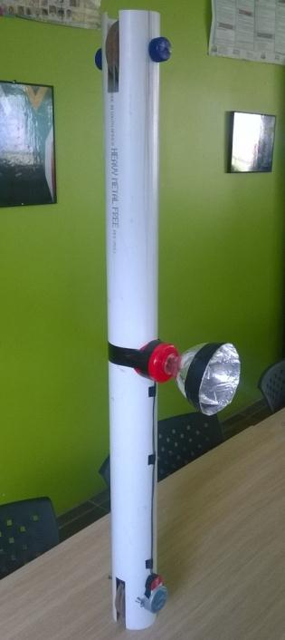
What is the Fliplamp?
It is a lamp that is powered by rotating it around.
The Fliplamp is a pipe with a weight hanging from a pulley connected to a generator that causes the generator to make electricity. This electricity powers a lamp for about 18 seconds. Once at the bottom, it can be reset by turning the Fliplamp around again.

Operation
A person would hold the Fliplamp in their hands and rotate it upside down. When the Fliplamp is upside down, a bottle of sand inside a pipe will move downwards as result of gravity. This downward motion will rotate two pulleys on either end of the pipe. One of the pulleys has a microwave motor attached to its shaft. When this motor turns it will generate a voltage. The output of the motor is connected to LEDs that are connected in a series-parallel configuration. It takes the bottle 18 seconds to reach the bottom of the pipe. After the bottle has reached the bottom the user can rotate the Fliplamp again to cause the same process to repeat.

Advantages
- It is mobile and can therefore be carried anywhere needed.
- It is not connected to any external supplies, thus off grid.
- The Fliplamp uses no batteries
- It is built from recyclable materials found commonly.
- It is environmentally friendly and the energy is only used when needed.
- It can be used inside and outside.

Use
People in rural or poor communities can build a Fliplamp with only a few needed components. They can use this lamp to have light inside a house and especially outside when needing to walk in the dark. Once the lamp is built correctly, it will never need any batteries/chargers. The only energy it uses is from lifting it with the hand and by the person carrying it.

Parts used
Part | Technical
Pipe | 1x PVC pipe, 80mm Diameter
Wood | 1x wooden plank 100x200x15mm + 1x broom stick 200mm
Wire | Any scrap wires
Nails | 3x
Motor | 1x microwave motor (synchronous motor)
LEDs | 12x 3v LEDs
Bottles | 1x bottle 750ml + 1x coke bottle 2l
Sand | Bucket of sand and any heavy objects
Sandpaper | 1x sandpaper 200x600mm
Straws | 4x Straws
Washers | 2 washers
Tape | Roll of tape
Foil | Pieces of foil
These parts can be changed for any other part that can do the same function. Ex. Use gutter for pipe or use Cans for pulleys.

Tools

- Saw
- Hammer
- Screwdriver
- File
- Scissors
- Glue
- Pliers

The future of the Fliplamp
The Fliplamp can still be improved a lot when given the time. The time the light is on can be increased by creating a better pulley system. More pulleys can transfer more weight to rotation. There is also the option of using a better motor which will require less weight. Increasing the distance of the pipe can increase the time it takes to show light. The Fliplamp is designed with recyclable materials in mind and can thus be improved with any better materials used.
We would love to spend more time on the project and think of new things to improve the system or by using the principle in another way. We also want to find alternatives to some components for if a person cannot find some of the parts used.

Fliplamp building tutorial
The Fliplamp has 4 main parts:
- Pipe
- Pulleys
- Lamp
- Bottle
Steps to make each part:
Pipe | Use a pipe of 1m that a bottle can fit into smoothly, and cut 2 square slits on each side opposite each other with a hacksaw. | 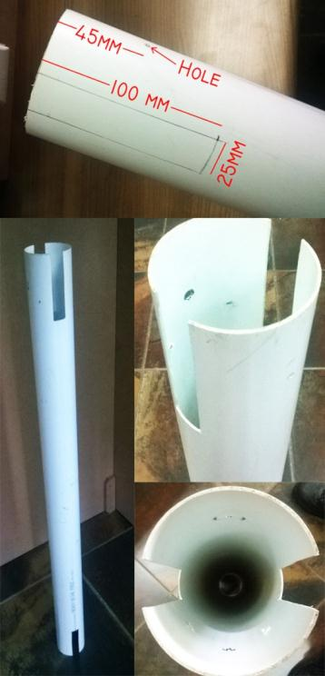
 | Use a screwdriver to make 2 holes on each side opposite each other.
Pulley | Do the following instructions twice as the project needs 2 pulleys. | 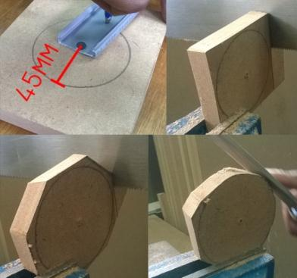  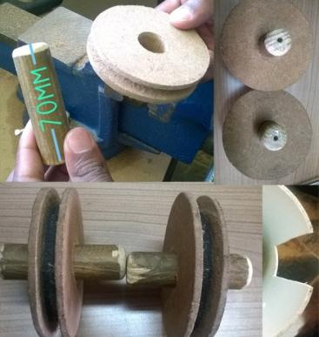
 | Draw with a pencil a circle with the radius of 45mm on the wooden piece and use a saw to cut a circle piece of wood.
 | Using a file, Scrape slots on the outer edge of the circle so that it will have the shape of a pulley. Cut strips of sandpaper to fit into the slots and glue them in place.
 | Use a sharp object or a drill to make a hole in the center of the pulley.
 | Take a broom stick and cut it 70mm long. Fit this piece into the pulley’s hole.
Lamp | Cut the top of a bottle off. Take a plastic holder and cut a hole inside for the bottle thread to fit into. | 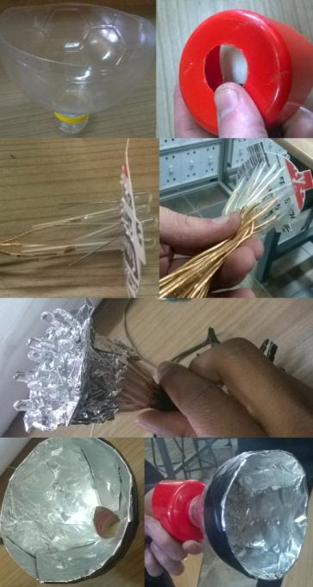
 | Take the plastic from a lid and cut a circle to fit into the bottle. Press ±12 LEDs into this circle. Connect a wire to each LED. Using tape, tape everything inside the plastic holder.
 | Use the diagram to connect the LEDs to each other.
Circuit Diagram

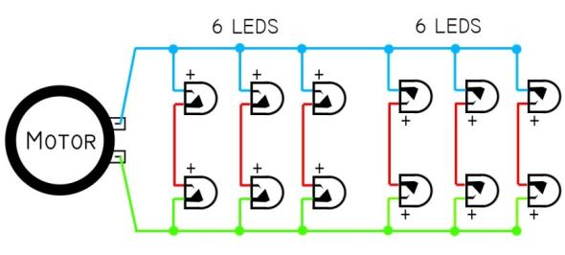
Bottle | Make two holes on each side of a small bottle and tie a rope or wire into it. The rope must make a complete circle of 187mm. | 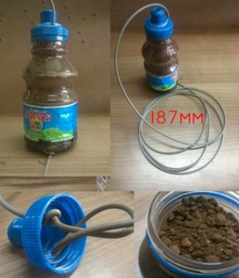
 | Full the bottle with sand and any heavy objects and close the bottle. To tighten the wire, simply open the bottle cap and make a knot.

Steps to put parts together:
Putting it all together | Put a pulley in the slits of the pipe. Take a nail and hammer it in on the sides through the hole on the one side. On the other side, put the microwave motor through the hole to connect to the shaft. | 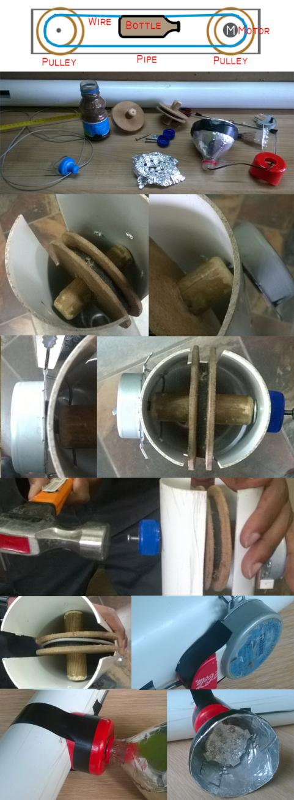
 | Tie the motor using some wires or tape.
 | Put the bottle with wire around one pulley and put the bottle cap back.
 | Put the other pulley in the slit and before putting a nail, pull the bottle wire around the pulley in place.
 | Connect the LEDs in parallel with 2 and connect the input to the motor using straws as insulation. Circuit diagram available.
 | Use foil to cover the inside of the lamp to increase light.
Use tape to tape loose parts together. If the pulley slips, just tighten it in the bottle.

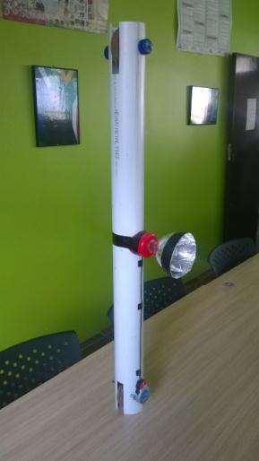

Team
Luvo Dubula, Lafras Magabe, Clayton Maartens
Special thanks
Prof Alexandre Sebastiani, Jonathan Kabanga, Team Isibani
Education is the movement from darkness to light.
French South African Schneider Electric Education Centre

